SMARTSHELF
A Web-Based Library Management System

PROJECT PROPOSAL REPORT
Module Code | HDIT 21193
Module | User Experience and Interface Design
Academic Year | Year 2, Semester 1
Credits | 3
Project Type | Complete Web Application
Technologies | HTML, CSS, JavaScript, PHP, MySQL (no frameworks)
Submitted in partial fulfilment of the requirements of the module
User Experience and Interface Design (HDIT 21193)

Table of Contents

1. Introduction
For as long as libraries have existed, they have depended on careful record-keeping to do their work. In many institutions, however, that record-keeping is still carried out by hand. A member looking for a particular title may have to consult a printed catalogue or ask a member of staff to check the shelves; loans are written into a register; due dates are tracked on cards; and fines are worked out with a calculator at the counter. These practices are familiar and, on a small scale, they function. The difficulty is that they no longer match the expectations of the people who use libraries today.
Readers have grown accustomed to searching for information instantly, from whichever device happens to be in their hand, and to receiving reminders and confirmations without having to ask. A library that cannot offer at least a comparable level of convenience risks appearing slower and less accessible than it really is. Manual processes also introduce errors that are easy to make and hard to detect: a copy marked as available when it is not, a fine that is miscalculated, or an overdue notice that is simply never sent.
SmartShelf has been designed and built to close this gap. It is a complete, web-based library management system that brings the entire borrowing lifecycle — searching, borrowing, returning, reserving, fine settlement and reporting — into a single, secure and responsive application. Rather than relying on an established framework such as Laravel, React or WordPress, the system has been implemented directly with the core web technologies of HTML, CSS, JavaScript, PHP and MySQL. This choice was deliberate. Building each component from first principles demonstrates a genuine command of how the web works beneath the abstractions, and it keeps every part of the system fully under the developer's control, with no hidden behaviour inherited from a third party.
This report sets out the reasoning behind the project. It examines the shortcomings of conventional practice, states the aims and objectives that follow from them, defines the boundaries of the system, and explains the architectural, database, security and design decisions that shaped the finished application. Taken together, these sections describe not only what SmartShelf does, but why it was built the way it was.

2. Problem Statement
A close look at the way libraries are commonly run reveals a set of recurring problems. None of them is dramatic on its own, but together they make the service slower for members and more laborious for staff. Each has been treated in this project as a firm requirement to be met, rather than as an optional improvement to be added if time allowed.
- Inefficient book searching. Without a proper search facility, both members and staff are left to locate titles by hand. On a busy day this wastes time that neither party can easily spare, and it discourages members from exploring the collection.
- Manual inventory management. When copy counts are maintained by hand, they drift out of step with reality. A title may be shown as available when every copy is on loan, or the reverse, and the resulting confusion undermines confidence in the whole catalogue.
- Inadequate overdue tracking. Fines calculated manually are prone to error, and reminders are rarely sent at all. The predictable consequence is that items are returned late or, in some cases, not returned.
- Limited member interaction. Members typically cannot reserve a title that is currently out, review what they have borrowed in the past, or read anything online. Their relationship with the library ends at the counter.
- Poor reporting. Management is left with little visibility of how the collection is actually used — which titles are popular, who borrows most, and where resources are under- or over-stretched.
- Absence of digital services. Very few traditional systems offer any electronic or remote access to materials, so a member must physically attend the library to make use of it.
The table below summarises how each problem affects the service and how SmartShelf responds to it.
Problem | Effect on the service | SmartShelf's response
Inefficient searching | Slow retrieval; poor discovery | Instant search by title, author or ISBN with filters
Manual inventory | Inaccurate availability | Stock counts updated automatically in real time
Weak overdue tracking | Late returns; lost items | Automatic fine calculation and timely reminders
Limited interaction | Members feel disconnected | Reservations, history, reviews and eBooks
Poor reporting | Decisions made without data | Analytical dashboards for staff and management
No digital access | Physical attendance required | A digital library of readable, downloadable titles
Table 1. Summary of problems addressed and the corresponding response.

3. Aim and Objectives

3.1 Aim
The aim of the project is to design and build a secure, responsive and genuinely usable library management system that modernises the borrowing experience for members and staff alike, replacing manual routine with dependable automation while keeping the interface clear and approachable.

3.2 Objectives
To realise this aim, the project pursues the following specific objectives:
- To give members an efficient way to search, borrow, reserve and read library materials, whether they are at the library or elsewhere.
- To automate inventory management so that the availability of every title is kept accurate and up to date without manual intervention.
- To calculate fines automatically and to notify members of deadlines that are approaching or have passed.
- To provide librarians and administrators with clear dashboards and reporting tools that turn day-to-day activity into useful information.
- To incorporate modern, practical features — including QR-code identification, book recommendations and a digital eBook library — that raise the system above the merely functional.
- To ensure that the system is secure, accessible and fully responsive across desktop, tablet and mobile devices.

4. Scope of the System
SmartShelf covers the complete lifecycle of everyday library operations. In practical terms, this means that the system takes responsibility for a member from the moment they register through every subsequent interaction with the collection.

4.1 Within scope
- User registration, authentication and role-based access control.
- Catalogue management, including the addition, editing and classification of titles.
- The full issue-and-return workflow, with availability updated in real time.
- A reservation queue for titles that are currently on loan.
- Automatic fine calculation and the delivery of notifications.
- Administrative reporting and analytical dashboards.
- A digital library component allowing selected titles to be read and downloaded electronically.
- Public-facing pages through which prospective members can browse the catalogue and learn about the service.

4.2 Outside scope
So that the project remains focused and achievable, certain areas have been deliberately placed outside its boundaries. These include integration with external payment gateways for the online settlement of fines, connection to national or inter-library catalogue networks, and the development of dedicated native mobile applications. The responsive web interface already serves mobile users well, and these exclusions represent natural directions for future work rather than gaps in the present system.

5. System Users and Roles
The system recognises three kinds of user, each given exactly the level of access that its responsibilities require and no more. Access is cumulative: a librarian can do everything a member can, and an administrator can do everything a librarian can, with additional privileges layered on top.

5.1 Members
Members are the primary users and the reason the library exists. A member may browse and search the catalogue, borrow and return titles, reserve items that are currently on loan, read and download eBooks, review their own borrowing history, keep track of any outstanding fines, and leave reviews and ratings for titles they have read.

5.2 Librarians
Librarians handle the day-to-day running of the service. In addition to everything a member can do, they issue and return books at the service desk, manage the reservation queue, maintain the catalogue, and use QR-code scanning to speed up transactions at the counter.

5.3 Administrators
Administrators hold full privileges over the system. Beyond all librarian functions, they manage user accounts, inspect the system activity log, and open the high-level analytical reports used to guide decisions. Access control is enforced consistently throughout the application, and any request that falls outside a user's permitted area is automatically redirected.
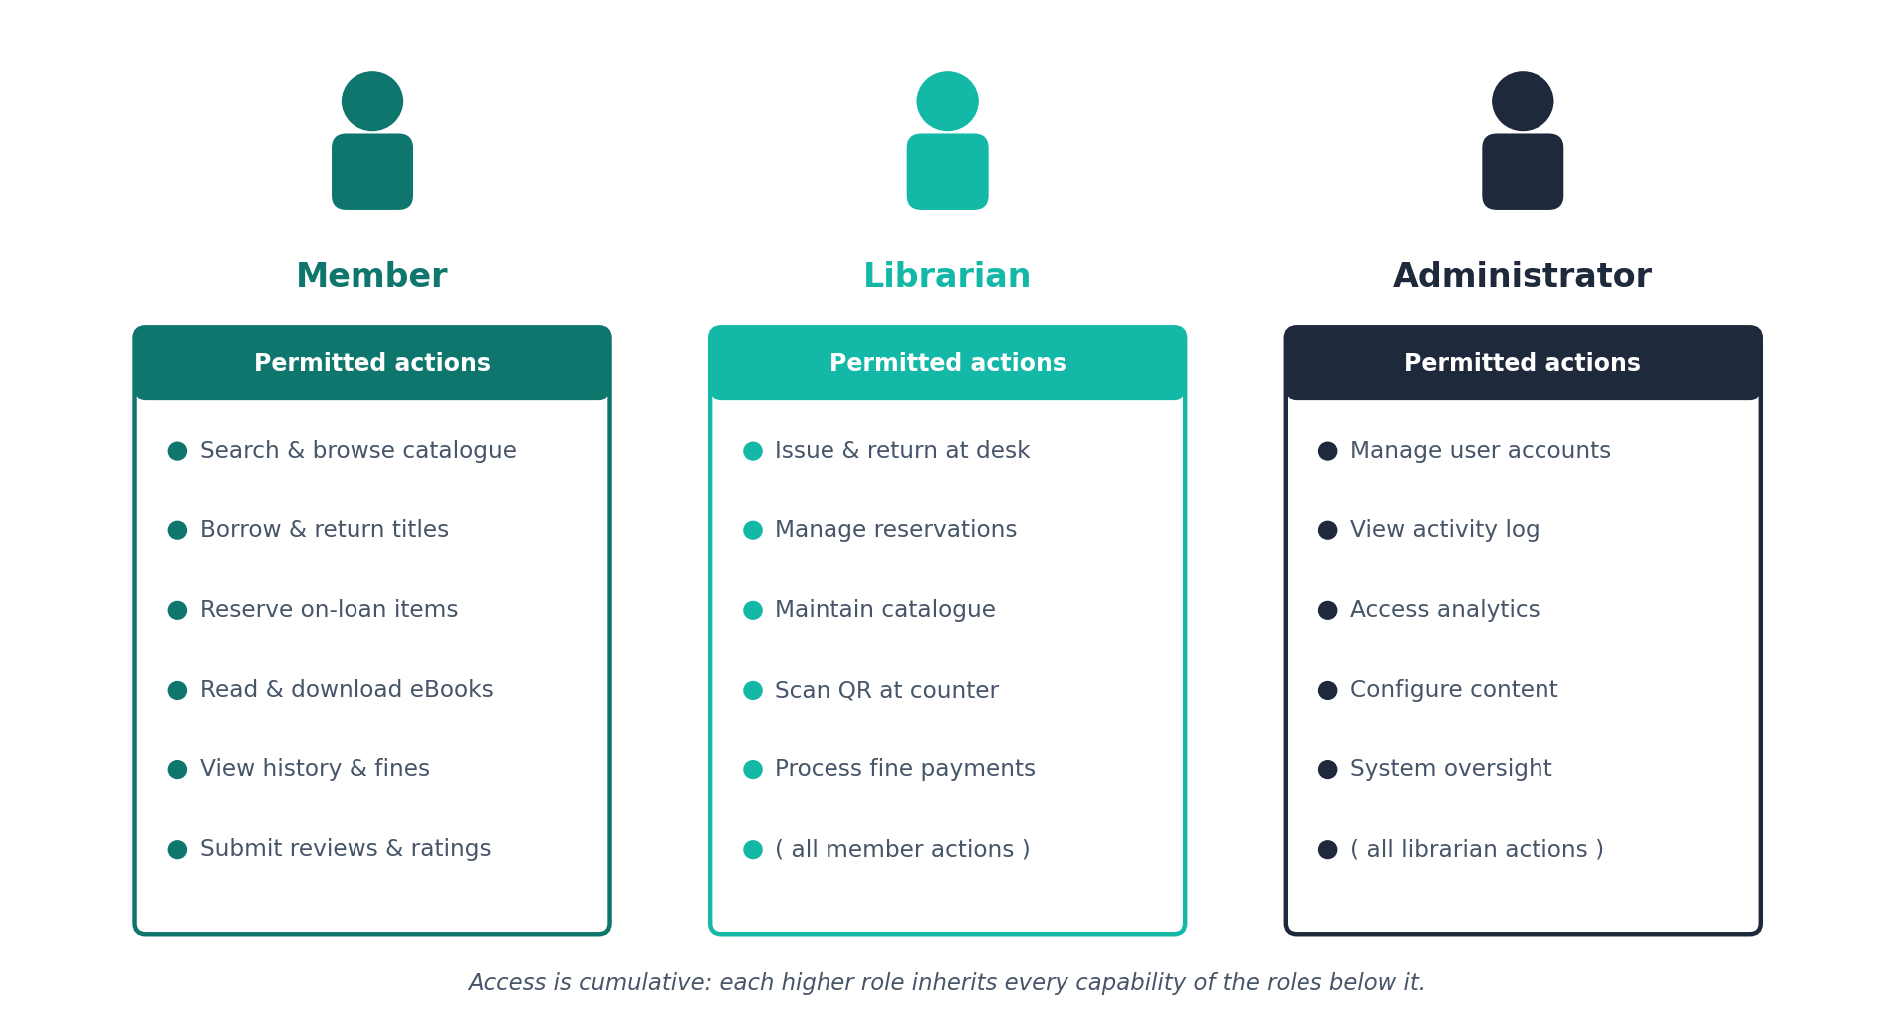
Figure 1. User roles and their permitted actions, showing cumulative access.

6. Functional Features

6.1 Core functionality
- A complete borrowing and returning workflow in which the number of available copies is adjusted the instant a transaction takes place.
- A reservation queue that automatically notifies the next member in line as soon as a returned title becomes available.
- Automatic fine calculation, recalculated at each login so that the figure a member sees is always current.
- Personal profiles and borrowing histories, together with the ability to submit reviews and ratings.
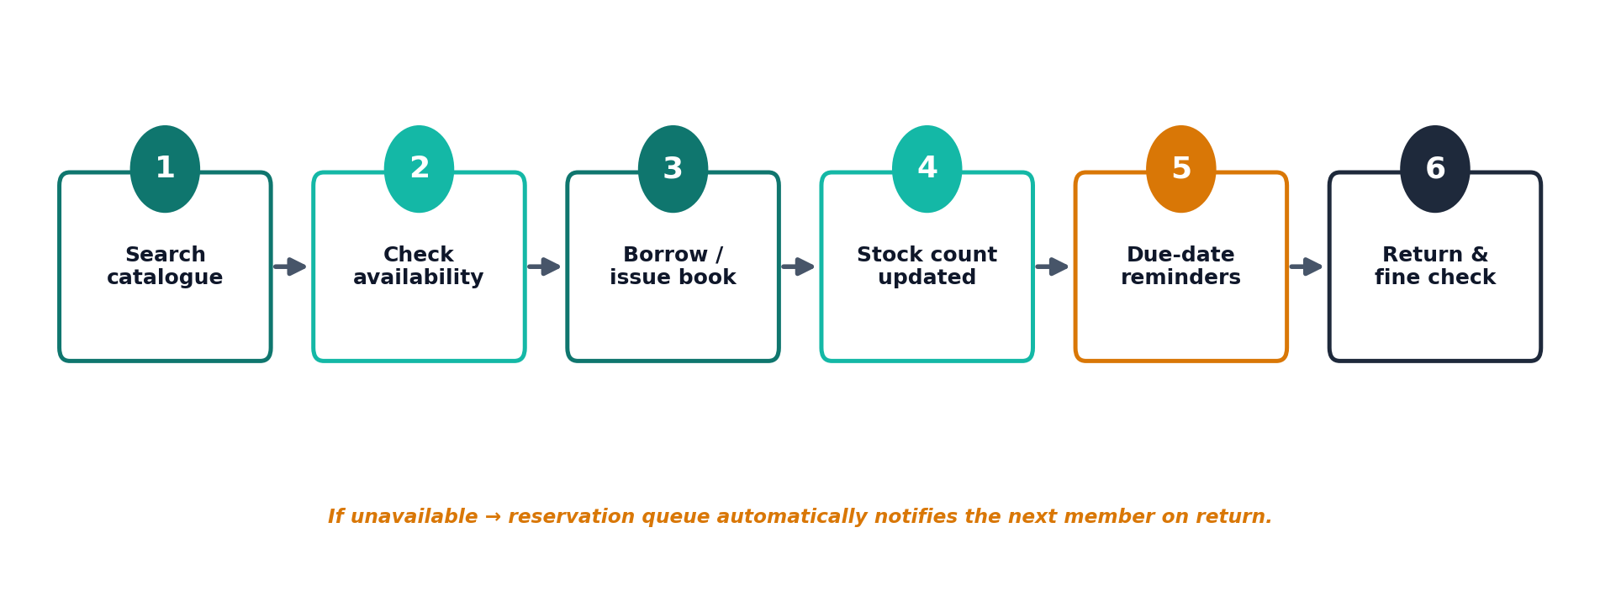
Figure 2. The core borrowing workflow, from search through to return and fine check.

6.2 Advanced features
- Smart search and filtering — instant results by title, author or ISBN, which can be narrowed by category and availability.
- Recommendation engine — suggestions drawn both from a member's own borrowing history and from the overall popularity of titles.
- QR-code identification — rapid issuing and returning of items by scanning at the counter.
- Digital library — selected titles that can be read on screen and downloaded as electronic documents.
- Automated notifications — alerts for approaching due dates, overdue items and reservations that have become available.
- Analytical dashboards — a clear view of borrowing trends, popular titles, leading borrowers and inventory utilisation.
- Light and dark display modes — a display preference that is remembered between sessions for comfort and accessibility.

7. System Architecture and Technologies
SmartShelf follows a conventional three-tier architecture, separating the system into a presentation layer, an application layer and a data layer. This separation is not merely tidy; it keeps each concern independent, so that the way information is displayed can change without disturbing the rules that govern it, and the rules can change without touching the way data is stored.
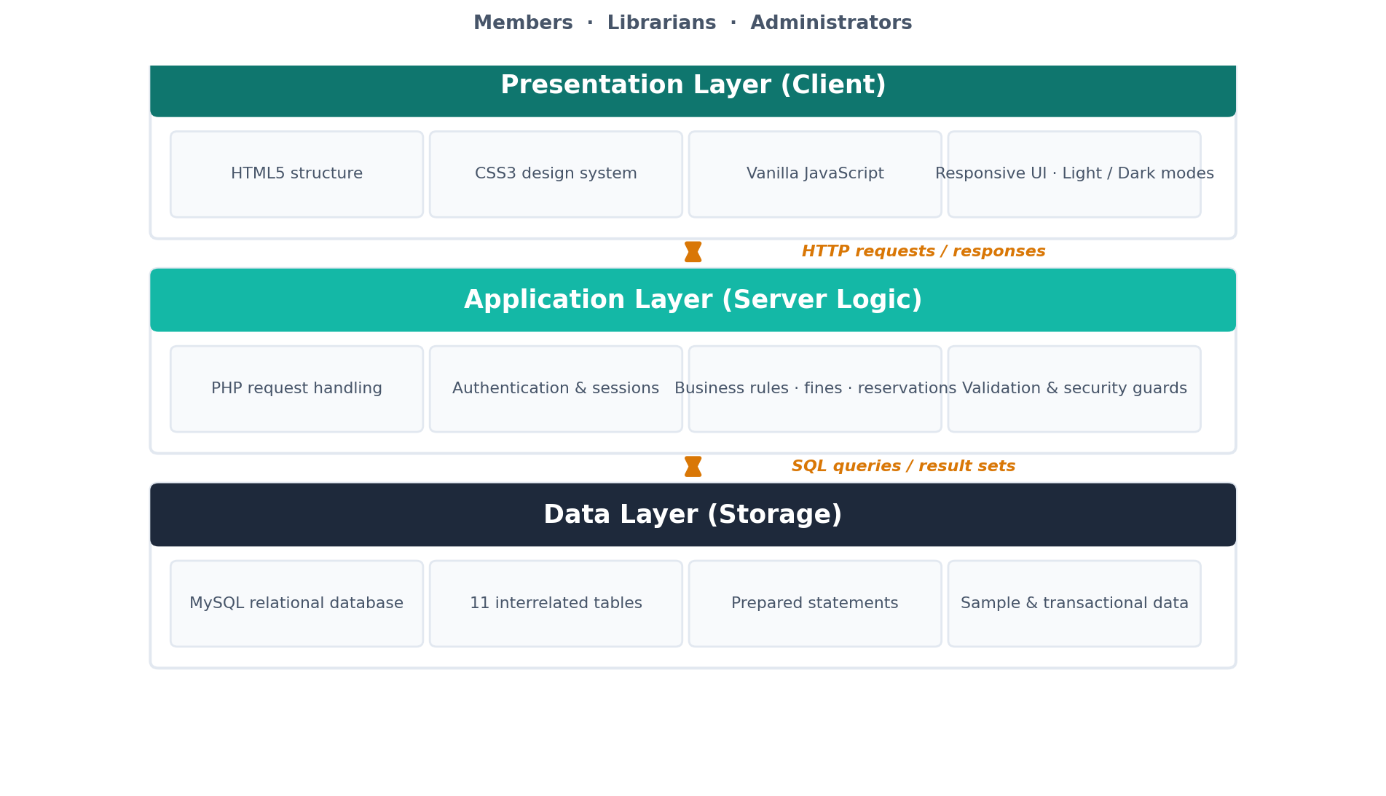
Figure 3. The three-tier architecture and the technologies used at each layer.
The technologies employed at each layer are summarised below.
Layer | Technology
Structure | HTML5
Presentation | CSS3, with a custom design system offering light and dark themes
Client logic | JavaScript (vanilla, no libraries)
Server logic | PHP
Data storage | MySQL
Table 2. Technologies used at each layer of the architecture.
To keep the codebase maintainable and free of duplication, the elements shared by every page — the database connection, the page header and footer, and a library of helper functions — are gathered in a single includes directory and pulled into each page as needed. The database connection itself is defined in one configuration file, so that a change of environment requires an edit in only one place. Stylesheets, client scripts and server-side code are kept in separate files, and the source is commented throughout so that its intent remains clear to anyone reading it later.

8. Database Design
The application is supported by a relational database of eleven interrelated tables — comfortably beyond the minimum of three required for the assignment. The design normalises the data so that each fact is stored once and relationships between records are expressed through keys rather than duplication. The principal tables are described below.
Table | Purpose
users | Account details, role and status for every user of the system.
books | The central catalogue, including stock levels, cover images and eBook files.
categories | The classification of books into subject groups.
features | Editable content displayed on the public Features page.
borrowings | A record of every issue and return transaction.
reservations | Reservation queues for titles that are currently on loan.
fines | A transparent ledger of the charges levied against members.
reviews | Member reviews and ratings for individual titles.
notifications | Alerts raised for due dates, reservations and other events.
contact_messages | Enquiries submitted through the public contact form.
activity_log | An audit trail of significant actions for accountability.
Table 3. The eleven tables of the SmartShelf database and their purpose.
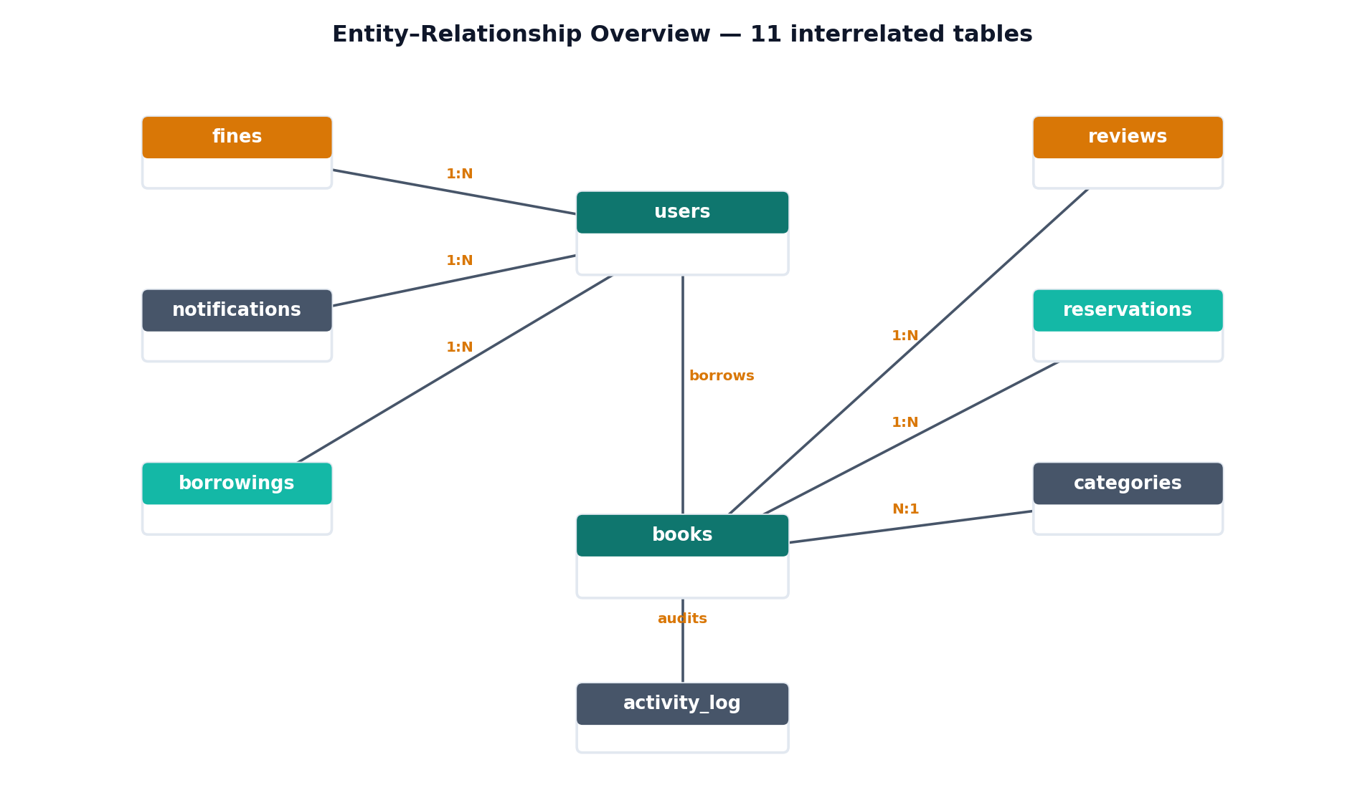
Figure 4. Entity–relationship overview showing how the principal tables connect.
Every table is populated with realistic sample data so that the system can be demonstrated convincingly from the moment it is installed. One detail deserves particular mention: borrowing dates are generated relative to the date of import rather than being fixed. As a result, the demonstration data always looks current, whatever day the system happens to be set up on, and features such as overdue detection can be seen working straight away.

9. Security Measures
Because the system holds personal accounts, security was treated as a foundation of the design rather than something to be bolted on at the end. The measures below address the most common and most serious threats to a web application of this kind.
Threat / concern | Measure implemented
Password protection | Passwords are hashed with PHP's password_hash() and checked with password_verify(); plain-text passwords are never stored.
SQL injection | Every database interaction uses prepared statements, removing the possibility of injected queries.
Cross-site scripting | User input is sanitised on submission and escaped on output, so that injected scripts cannot run.
Cross-site request forgery | Every form carries a CSRF token, and any submission without a valid token is rejected.
Session security | Sessions use HttpOnly and SameSite cookies, and the session identifier is regenerated at login to prevent fixation.
Access control | Page-level guards confine each role to its permitted areas of the application.
Table 4. Security threats and the measures taken against them.
Validation is carried out on both sides of the connection. On the client, JavaScript gives the user immediate feedback as they type; on the server, PHP performs the authoritative checks, on the principle that anything arriving from a browser must be verified again before it is trusted.

10. User Interface and Experience Design
Since the project belongs to the discipline of user experience and interface design, the look and feel of the system received particular care. A bespoke design system — defining a consistent colour palette, spacing scale, typography and set of reusable components — was created first and then applied uniformly across every page. The result is an application that feels coherent and considered rather than assembled piece by piece.
The interface is fully responsive. On a wide screen it presents a spacious dashboard; as the viewport narrows it reflows gracefully to a single column, and the navigation collapses into a menu suited to touch. A number of small interactive touches — animated statistics, hover effects, transitions that reveal content as the page scrolls, and a live password-strength indicator — make the system feel responsive and reliable without ever getting in the user's way. The choice between light and dark modes, remembered from one visit to the next, further improves comfort and accessibility for users working in different conditions.

11. Significance of the Project
What sets SmartShelf apart is that it is finished. There is no placeholder content and no half-implemented feature waiting to be completed later; every function described in this report works, and the application runs without modification in a standard XAMPP environment. It also reaches well beyond the stated requirements, adding QR-code identification, a recommendation engine and a digital library to the expected core.
The system has been checked from end to end — registration and login, borrowing and returning, reservation, fine settlement and reporting — against a live database, confirming that the functionality behaves as intended in practice and not merely in principle. Taken together, these qualities make SmartShelf a credible example of a system that could be deployed in a real library rather than a demonstration that stops at the surface.

12. Conclusion
SmartShelf sets out to remedy the familiar weaknesses of traditional library management — slow retrieval, inventory kept by hand, ineffective handling of overdue items and the absence of any digital service — and to do so with a single, practical, well-built application. It meets every requirement specified for the assignment and goes beyond them, adding the modern, thoughtfully chosen features that separate a system which merely works from one that is genuinely pleasant and efficient to use.
The outcome is a secure, responsive and complete web application. It is ready for submission, and, with only the natural extensions noted in the scope, it would be suitable for deployment in a working library. More than that, building it from the ground up in core web technologies has served its deeper purpose: to show a thorough, first-hand understanding of how a modern web application is designed, secured and made a pleasure to use.

